HOME PLANNER SOFTWARE

Abstract
This project titled “Home planner software” is used in organization, which deals with estimation details of the building construction. This project helps to estimate and maintain the construction process of the company and also maintains the labor details. This project reduces the manual calculation of construction details.
The modules of the raw material supplier details are maintained, their address, company name, cities are all maintained. The detailed module specifies the item purchase details with the cost.
The report generation is the main part which helps to generate print outs for various combination like estimation of each category that are raw material, electrical and painting.

Introduction
The objective of this project is to maintain the customer details and raw materials of the building in the construction company
In the big construction company the customer estimation may be mismatched with company made estimation and also there is possible for one customer information such that house design, estimation of raw materials may be entered in customer information. To avoid this problem separate database maintained in this project. So there is no possible for entering the wrong information.

Existing System
Existing system is manual system which contains many problems for collecting all the information regarding purchase, sales, labor charges etc. The main activities of the company are to construct commercial buildings, housing etc. The products used for construction and accounts of the company are done with the help of manual feeding of data. Since human manages all the activities belonging to the employee working in the company there are large chances for human error.
As there is lot of data work involved, skilled staffs are used. So it becomes dependable for the management on these people. The reports are not verified to the highest extend to avoid any miscommunication and misfortune of the company.
Existing system is a manual one is which all the transaction is maintained and producing report manually.

Disadvantages of existing system
- Processing takes along time
- It needs more employees
- Maintaining various records is difficult
- It requires more paper work
- It is a slow process
- Error are occurred
- Constant updating is impossible
- In accuracy in maintaining data
- Searching for a transaction is a tedious one
- Large number of stationary require

Proposed System

The proposed system has it own advantage such as quick in processing. The proposed system would avoid all the errors in the manual system. It also reduces human Labors and time. The existing system is found necessary to reduce the lot of manual work in the system. Proposed system is the computerization of the system with GUI based client server system, which takes care of the process involved.

Objectives
- The application gives the user easy to work with and also carryout all the purchase of raw materials.
- The proposed system is computerized using visual studio .Net as front end and Microsoft SQL Server 2000 as back end.
- The proposed system is very efficient & user friendly it generates timely and accurate factors.

Features and benefits of proposed system
    - Efficient recording of details at various stages
    - More efficient insertion, deletion and modification capabilities of the recorded details
    - New system should be user friendly with menus
    - Data redundancy avoided
    - Faster updating with greater amount of accuracy
    - Reducing the user typing and paper work
    - To save man power
    - Reduce work base & improving customer service

MODULE DESCRIPTION

The main objective of developing this project is to ease the maintenance of Construction Company, customer and also the employee details of the customer. The various modules are

- Master Module
This module includes the master details that are most frequently used items. In this customer database we enter the customer name, customer ID Number and personal address of the customer along with site (area) name in which he wants to build, type of the building whether it is single floor or double floor such a information’s are verified in the customer report.
After the customer details entered in the database then raw materials information’s are entered in the raw materials database depends upon the customer requirement. Raw material database consists of raw material name like sand, stone price of the raw material per square feet and estimation of the raw materials as per customer requirement.

      - Raw Material Collection
      - Customer Details

- Transaction module
The estimation of the electrical raw material like switches and number of lights, fans etc are entered in the electrical raw material database. Similarly the estimation of stair case septic tank and dispersion trench and unforeseen items are entered in the database. Above those information’s are verified in the report.

We also maintain the estimation of painting, white washing labor charge. The raw material information gathered from the master module. These values include the paint color and price of the materials.

We also maintain the estimation of foundation details, earth work, wood work, labor charge of earth work, flooring concrete and RCC roof slab. Finally in this project we compare overall estimation of the customer estimation and construction company estimation of the building. The works covered for the transaction modules such as,

      - Painting
      - White Washing
      - Earth Work
      - Wood Work
      - Electrician Work

- Estimation module
This project is very useful for Construction Company as well as customer. All the estimation is done in the system based user interface. So there is no possible to cause the error and also there is no possible entry of bargain between Construction Company and customers. This includes the unforeseen estimation and over all estimation of the construction work.

This Project is developed in VB.NET with the database in SQL Server2000. With an improved integrated development environment (IDE) and a significantly reduced startup time, Visual Basic .NET offers fast, automatic formatting of code as you type, improved IntelliSense, an enhanced object browser and XML designer, and much more. Database MSSQL Server 2000 is very essential RDBMS to develop application and it is very simple to create and maintain. The works covered for the estimation modules such as,

      - Unforeseen Estimation
      - Labor Charge Estimation
      - Overall Estimation

System Specification
Application Specification
Software Used
Operating System : Windows 10
Front end : Visual Studio .Net 2008
Back end : SQL SERVER 2005
Hardware Specification
Processor : i3
Memory : 4GB RAM
Hard Disk : 500 GB HDD
Keyboard : Microtek multimedia 110 Keys
Mouse : Logitech 3 button Mouse.
Monitor : 15” LED Samtron Monitor

SYSTEM ENVIRONMENT
WHAT IS “.NET”?
Microsoft .net is a set of micro soft software technologies for rapidly building and integrating xml web services, micro soft windows-based applications, and web solutions. The .net framework is a language-neutral platform for writing programs that can easily and securely interoperate. There’s no language barrier with .net: there are numerous languages available to the developer including managed c++, c#, visual basic and java script.
The .net framework provides the foundation for components to interact seamlessly, whether locally or remotely on different platforms. It standardizes common data types and communications protocols so that components created in different languages can easily interoperate.

“.net” is also the collective name given to various software components built upon the .net platform. These will be both products (visual studio.net and windows.net server, for instance) and services (like passport, .net my services, and so on).

The .net framework
The .net framework has two main parts:
1. The common language runtime (clr).
2. A hierarchical set of class libraries.
The clr is described as the “execution engine” of .net. It provides the environment within which programs run. The most important features are:

- Conversion from a low-level assembler-style language, called intermediate language (il), into code native to the platform being executed on.
- Memory management, notably including garbage collection.
- Checking and enforcing security restrictions on the running code.
- Loading and executing programs, with version control and other such features.
- The following features of the .net framework are also worth description:

Managed code - is code that targets .net, and which contains certain extra information - “metadata” - to describe itself. Whilst both managed and unmanaged code can run in the runtime, only managed code contains the information that allows the clr to guarantee, for instance, safe execution and interoperability.
Managed data - with managed code comes managed data. Clr provides memory allocation and deal location facilities, and garbage collection. Some .net languages use managed data by default, such as c#, visual basic.net and jscript.net, whereas others, namely c++, do not. Targeting clr can, depending on the language you’re using, impose certain constraints on the features available. As with managed and unmanaged code, one can have both managed and unmanaged data in .net applications - data that doesn’t get garbage collected but instead is looked after by unmanaged code.
Common type system - the clr uses something called the common type system (cts) to strictly enforce type-safety. This ensures that all classes are compatible with each other, by describing types in a common way. Cts define how types work within the runtime, which enables types in one language to interoperate with types in another language, including cross-language exception handling. As well as ensuring that types are only used in appropriate ways, the runtime also ensures that code doesn’t attempt to access memory that hasn’t been allocated to it.
Common language specification - the clr provides built-in support for language interoperability. To ensure that you can develop managed code that can be fully used by developers using any programming language, a set of language features and rules for using them called the common language specification (cls) has been defined. Components that follow these rules and expose only cls features are considered cls-compliant.

The class library

.net provides a single-rooted hierarchy of classes, containing over 7000 types. The root of the namespace is called system; this contains basic types like byte, double, boolean, and string, as well as object. All objects derive from system. Object. As well as objects, there are value types. Value types can be allocated on the stack, which can provide useful flexibility. There are also efficient means of converting value types to object types if and when necessary.
The set of classes is pretty comprehensive, providing collections, file, screen, and network i/o, threading, and so on, as well as xml and database connectivity.
The class library is subdivided into a number of sets (or namespaces), each providing distinct areas of functionality, with dependencies between the namespaces kept to a minimum.

Languages supported by .net

The multi-language capability of the .net framework and visual studio .net enables developers to use their existing programming skills to build all types of applications and xml web services. The .net framework supports new versions of Microsoft’s old favorite’s visual basic and c++ (as vb.net and managed c++), but there are also a number of new additions to the family:

Visual basic .net has been updated to include many new and improved language features that make it a powerful object-oriented programming language. These features include inheritance, interfaces, and overloading, among others. Visual basic also now supports structured exception handling, custom attributes and also supports multi-threading.

Visual basic .net is also cls compliant, which means that any cls-compliant language can use the classes, objects, and components you create in visual basic .net.

Managed extensions for c++ and attributed programming are just some of the enhancements made to the c++ language. Managed extensions simplify the task of migrating existing c++ applications to the new .net framework.

C# is Microsoft’s new language. It’s a c-style language that is essentially “c++ for rapid application development”. Unlike other languages, its specification is just the grammar of the language. It has no standard library of its own, and instead has been designed with the intention of using the .net libraries as its own.
Microsoft visual j# .net provides the easiest transition for java-language developers into the world of xml web services and dramatically improves the interoperability of java-language programs with existing software written in a variety of other programming languages.

Active state has created visual Perl and visual python, which enable .net-aware applications to be built in either Perl or python. Both products can be integrated into the visual studio .net environment. Visual Perl includes support for active state’s Perl dev kit.
Other languages for which .net compilers are available include:

- Fortran
- Cobol
- Eiffel
Fig1 .net framework

asp.net  xml web services | windows forms
base class libraries
common language runtime
operating system

Introduction to asp.net

Asp.net is the .net framework layer that handles web requests for specific types of files, namely those with (.aspx or .ascx) extensions. The asp.net engine provides a robust object model for creating dynamic content and is loosely integrated into the .net framework.

What is asp.net?

Asp.net is part of the .net framework. Asp.net programs are centralized applications hosted on one or more web servers that respond dynamically to client requests. The responses are dynamic because asp.net intercepts requests for pages with a specific extension (.aspx or .ascx) and hands off the responsibility for answering those requests to just-in-time (jit) compiled code files that can build a response “on-the-fly.”

Asp.net deals specifically with configuration (web.config and machine.config) files, web services (asmx) files, and web forms (aspx) files. The server doesn’t “serve” any of these file types—it returns the appropriate content type to the client.
The configuration file types contain initialization and settings for a specific application or portion of an application. Another configuration file, called machine.web, contains machine-level initialization and settings. The server ignores requests for web files, because serving them might constitute a security breach.

Client requests for these file types cause the server to load, parse, and execute code to return a dynamic response. For web forms, the response usually consists of html or wml. Web forms maintain state by round-tripping user interface and other persistent values between the client and the server automatically for each request.

A request for a web form can use view state, session state, or application state to maintain values between requests. Both web forms and web services requests can take advantage of asp. Net’s integrated security and data access through ado.net, and can run code that uses system services to construct the response. So the major difference between a static request and a dynamic request is that a typical web request references a static file. The server reads the file and responds with the contents of the requested file.

Asp.net uses .net languages. Asp.net code exists in multithreaded jit compiled dll assemblies, which can be loaded on demand. Once loaded, the asp.net dlls can service multiple requests from a single in-memory copy.
Asp.net supports all the .net languages (currently c#, c++, vb.net, and jscript, but there are well over 20 different languages in development for .net), so you will eventually be able to write web applications in your choice of almost any modern programming language.

In addition to huge increases in speed and power, asp.net provides substantial development improvements, like seamless server-to-client debugging, automatic validation of form data.
Fig2. Interoperability
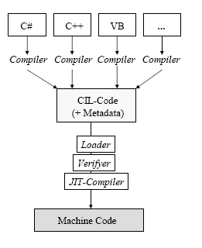

Asp.net events
.net events and why they are cool
Every time an asp.net page is viewed, many tasks are being performed behind the scenes. Tasks are performed at key points ("events") of the page's execution lifecycle.
The most common events are:

On init
The first event in our list to be raised is oninit. When this event is raised, all of the page's server controls are initialized with their property values. Post back values are not applied to the controls at this time.

On load
The next event to be raised is on load, which is the most important event of them all as all the pages server controls will have their post back values now.

Post back events
Next all the post back events are raised. These events are only raised when the page view is the result of a post back. The order that these events are raised can't be defined or relied upon; the only consistency with the order that post back events are raised is that they are all raised between the unload and onprerender events.
On pre render
This event is raised just prior to the page or server control's html output being written into the response stream that's sent to the client web browser. This is last chance you have to make any modifications. By this point, all the server controls on the page have the final data applied.
On unload
This is the last event in our list to be raised and you should destroy any un-managed objects and close any currently open database connection at this point. It is not possible to modify any controls on the page at this point as the response stream has already been sent to the client web browser.

As each event of the page is raised it also automatically tells all its child controls to raise their own implementation of the same event. In turn each of those controls will tell its own child controls to do the same and so on down the control tree till all controls have done so. Then execution flow is passed back to the main page class to continue onto the next event and the process is repeated for that event.
Main features of asp.net
Successor of active server pages (asp), but completely different architecture
• object-oriented
• event-based
• rich library of web controls
• separation of layout (html) and logic (e.g. C#)
• compiled languages instead of interpreted languages
• gui can be composed interactively with visual studio .net
• better state management

Namespaces

Asp.net uses a concept called namespaces. Namespaces are hierarchical object models that support various properties and methods. For example, html server controls reside in "system.web.ui.htmlcontrols" namespace, web server controls reside in “system.web.ui.webcontrols" namespace and ado+ resides in "system. Data" namespace.
Language independent

An asp.net page can be created in any language supported by .net framework. Currently .net framework supports vb, c#, jscript and managed c++.
Asp.net server controls
Using asp.net server controls, browser variation is handled because these controls output the html themselves based on the browser requesting the page.
Types of controls
Asp.net has two basic types of controls: html server controls and web server controls.html server controls are generated around specific html elements and the asp.net engine changes the attributes of the elements based on server-side code that you provide. Web server controls revolve more around the functional you need on the page. The asp.net engine takes the extra steps to decide based upon the container of the requester, what html to output.

Dwide field training
Ado.net
Ado.net provides a set of classes which a script can use to interact with databases. Scripts can create instances of ado.net data classes and access their properties and methods. A set of classes which work with a specific type of database is known as a .net data provider. Ado.net comes with two data providers, the sql server.net data provider (which provides optimised access for microsoft sql server databases) and the oledb.net data provider, which works with a range of databases. The main ado.net oledb data access classes are oledbconnection, oledbcommand, oledbdatareader and oledbdataadapter.

Features of visual basic .net

Visual studio .net is the single ide that all the .net languages can use. It makes everything available to all languages.
Visual studio .net is a great multilanguage development environment and offers a complete set of tools to build windows forms , asp.net web applications , and xml web services.
Start page

The start page offers three tabs at the top of the window that enables to modify visual studio.net as well as find important information. The tabs are

html server controls versus web server controls
control type | when to use this control type
Html server controls | When converting traditional asp 3.0 web pages to asp.net web pages and speed of completion is a concern. It is a lot easier to change your html elements to html server controls than it is to change them to web server controls.  When you prefer a more html-type programming model.  When you wish to explicitly control the code that is generated for the browser.
Web server controls | When you require a rich set of functionality to perform complicated page requirements.  When you are developing web pages that will be viewed by a multitude of browser types and that require different code based on these types.  When you prefer a more visual basic-type programming model that is based on the use of controls and control properties.

Projects tab this tab is the one to start new projects and launch projects that already exists. This tab lets you to create a new project or open an existing project.
Online resources tab this tab provides a number of online resources when connected to the internet.
My profile tab this tab enables to customize the visual studio.net environment to resemble the structured environment that is familiar with.
Server explorer
This window enables to perform a number of functions such as database connectivity, performance monitoring, and interacting with event logs.
By using server explorer you can log on to a remote server and view database and system data about that server. Many of the functions that are performed with the enterprise manager in sql server can now be executed in the server explorer.

Solution explorer
This provides an organized view of the projects in the application.
The toolbar within the solution explorer enables to
- View code page of the selected item.
- View design page of the selected item.
- Refresh the state of the selected item.
- Copy the web project between web servers.
- Show all the files in the project, including the hidden files.
- See properties of the selected item.
Class view
The class view window can be viewed from the start page by clicking the class view tab. The class view shows all the classes that are contained within your solution.
The class view shows the hierarchical relationship among the classes in your solution as well as the number of other items including methods, enumerations, namespaces, unions, and events. It is possible to organize the view of these items within the window by right-clicking anywhere in the class view area and choosing how the items are sorted.
Toolbox
The toolbox window enables to specify elements that will be part of the windows forms or web forms. It provides a drag and drop means of adding elements and controls to the pages or forms. The code snippets can also be stored within the toolbox.
Properties window
This window provides the properties of an item that is part of the application. This enables to control the style and behavior of the item selected to modify.
Dynamic help
This window shows a list of help topics. The help topics change based on the item selected or the action being taken.
The dynamic help window shows the help items displayed when you have a button control on the page selected. After the item is selected, a list of targeted help topic is displayed. The topics are organized as a list of links. Clicking one of the links in the dynamic help window opens the selected help topic in the document window.
Document window
The document window is the main window within visual studio.net where the applications are built.
The document window shows open files in either design or html mode. Each open file is represented by a tab at the top of the document window. Any number of files can be kept open at the same time, and you can switch between the open files by clicking the appropriate tab.
Design mode versus html mode
Visual studio.net offers two modes for viewing and building files: design and html. By clicking the design tab at the bottom of the document window, you can see how the page will view to the user. The page is built in the design mode by dragging and dropping elements directly onto the design page or form. Visual studio .net automatically generates the appropriate code.
When the page is viewed in html mode, it shows the code for the page. It enables to directly modify the code to change the way in which the page is presented.
Working with sql server through the server explorer
Using visual studio.net , there is no need to open the enterprise manager from sql server. Visual studio.net has the sql servers tab within the server explorer that gives a list of all the servers that are connected to those having sql server on them. Opening up a particular server tab gives five options:

- Database diagrams
- Tables
- Views
- Stored procedures
- Functions
Database diagrams
To create a new diagram right click database diagrams and select new diagram. The add tables dialog enables to select one to all the tables that you want in the visual diagram you are going to create.
Visual studio .net looks at all the relationships between the tables and then creates a diagram that opens in the document window.
Each table is represented in the diagram and a list of all the columns that are available in that particular table. Each relationship between tables is represented by a connection line between those tables.
The properties of the relationship can be viewed by right clicking the relationship line.
Tables
The server explorer allows towork directly with the tables in sql server. It gives a list of tables contained in the particular database selected.
By double clicking one of the tables, the table is seen in the document window. This grid of data shows all the columns and rows of data contained in the particular table.
The data can be added or deleted from the table grid directly in the document window. To add a new row of data, move to the bottom of the table and type in a new row of data after selecting the first column of the first blank row. You can also delete a row of data from the table by right clicking the gray box at the left end of the row and selecting delete.
By right clicking the gray box at the far left end of the row, the primary key can be set for that particular column. The relationships to columns in other tables can be set by selecting the relationships option.
To create a new table right-click the tables section within the server explorer and selecting new table. This gives the design view that enables to start specifying the columns and column details about the table.
To run queries against the tables in visual studio .net, open the view of the query toolbar by choosing view->toolbars->query.
To query a specific table, open that table in the document window. Then click the sql button which divides the document window into two panes-one for query and other to show results gathered from the query.
The query is executed by clicking the execute query button and the result is produced in the lower pane of the document window.

Views
To create a new view, right-click the view node and select new view. The add table dialog box enables to select the tables from which the view is produced. The next pane enables to customize the appearance of the data in the view.

features of sql-server

The olap services feature available in sql server version 7.0 is now called sql server 2000 analysis services. The term olap services has been replaced with the term analysis services. Analysis services also includes a new data mining component. The repository component available in sql server version 7.0 is now called microsoft sql server 2000 meta data services. References to the component now use the term meta data services. The term repository is used only in reference to the repository engine within meta data services
Sql-server database consist of six type of objects,
They are,
1. Table
2. Query
3. Form
4. Report
5. Macro
Table
A database is a collection of data about a specific topic.
Views of table
We can work with a table in two types,
1. Design view
2. Datasheet view
Design view
To build or modify the structure of a table we work in the table design view. We can specify what kind of data will be hold.
Datasheet view
To add, edit or analyses the data itself we work in tables datasheet view mode.

Query
A query is a question that has to be asked the data. Access gathers data that answers the question from one or more table. The data that make up the answer is either dynaset (if you edit it) or a snapshot(it cannot be edited).each time we run query, we get latest information in the dynaset.access either displays the dynaset or snapshot for us to view or perform an action on it ,such as deleting or updating.

Forms
A form is used to view and edit information in the database record by record .a form displays only the information we want to see in the way we want to see it. Forms use the familiar controls such as textboxes and checkboxes. This makes viewing and entering data easy.
Views of form
We can work with forms in several primarily there are two views,
They are,
1. Design view
2. Form view
Design view
To build or modify the structure of a form, we work in forms design view. We can add control to the form that are bound to fields in a table or query, includes textboxes, option buttons, graphs and pictures.
Form view
The form view which display the whole design of the form.
Report
A report is used to vies and print information from the database. The report can ground records into many levels and compute totals and average by checking values from many records at once. Also the report is attractive and distinctive because we have control over the size and appearance of it.

Macro
A macro is a set of actions. Each action in macros does something. Such as opening a form or printing a report .we write macros to automate the common tasks the work easy and save the time.

SYSTEM STUDY
FEASIBILITY STUDY
The feasibility of the project is analyzed in this phase and business proposal is put forth with a very general plan for the project and some cost estimates. During system analysis the feasibility study of the proposed system is to be carried out. This is to ensure that the proposed system is not a burden to the company. For feasibility analysis, some understanding of the major requirements for the system is essential.
Three key considerations involved in the feasibility analysis are

- ECONOMICAL FEASIBILITY
- TECHNICAL FEASIBILITY
- SOCIAL FEASIBILITY

ECONOMICAL FEASIBILITY:

This study is carried out to check the economic impact that the system will have on the organization. The amount of fund that the company can pour into the research and development of the system is limited. The expenditures must be justified. Thus the developed system as well within the budget and this was achieved because most of the technologies used are freely available. Only the customized products had to be purchased.

TECHNICAL FEASIBILITY:

This study is carried out to check the technical feasibility, that is, the technical requirements of the system. Any system developed must not have a high demand on the available technical resources. This will lead to high demands on the available technical resources. This will lead to high demands being placed on the client. The developed system must have a modest requirement, as only minimal or null changes are required for implementing this system.

SOCIAL FEASIBILITY:

The aspect of study is to check the level of acceptance of the system by the user. This includes the process of training the user to use the system efficiently. The user must not feel threatened by the system, instead must accept it as a necessity. The level of acceptance by the users solely depends on the methods that are employed to educate the user about the system and to make him familiar with it. His level of confidence must be raised so that he is also able to make some constructive criticism, which is welcomed, as he is the final user of the system.
SYSTEM DESIGN
INPUT DESIGN

Input design is the process of converting user-originated inputs to a computer-based format. Input design is one of the most expensive phases of the operation of computerized system and is often the major problem of a system. In the project, the input design is made in various web forms with various methods.

For example, in the Admin form, the empty username and password is not allowed. The username if exists in the database, the input is considered to be invalid and is not accepted. Likewise, during the “Puchase” process, we purchase more than one products.

OUTPUT DESIGN

Output design generally refers to the results and information that are generated by the system for many end-users; output is the main reason for developing the system and the basis on which they evaluate the usefulness of the application.

In the project, the output is to view the products, purchase items, updated price list by the current product rate.

DATABASE DESIGN:

The database design is a must for any application developed especially more for the data store projects. Since the chatting method involves storing the message in the table and produced to the sender and receiver, proper handling of the table is a must.

In the project, login table is designed to be unique in accepting the username and the length of the username and password should be greater than zero.

In this database design the admin details and the user details are stored in the database. The different users view the data in different format according to the privileges given.

The complete listing of the tables and their fields are provided in the annexure under the title ‘Table Structure’.

Table Design

Customer
Primary key:sid
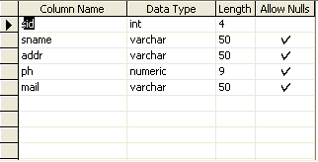

Product
Primary key:proid
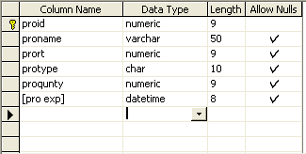
Supplier
Primary key:sid
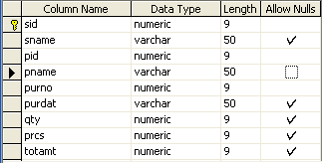
Purchase

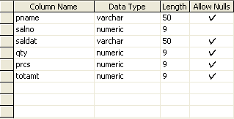
Quotation
Primary key:billno
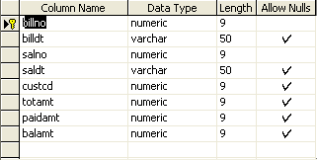

Data Flow Diagram
Level Diagrams:

Level 0:

User Name
Password

Login Verification
Exit
Yes
No

Estimation Details

Level 1:

Login
User

Employee
Employee

Purchase Item

Raw Material Detail
Item

Customer
Customer
Estimation

Estimation

Level 2:

View details
Estimation
Item

User

Customer

Estimation Module

ER Diagram

name
cid
mid
phno
Address
Customer
product
pid
Prorate
pname
Pro type
emp
Salary
doj
eid
dob
Name
Purchase details
Pu id
qnty
Pur name
type
Estimation

SYSTEM TESTING AND MAINTENANCE

Testing is vital to the success of the system. System testing makes a logical assumption that if all parts of the system are correct, the goal will be successfully achieved. In the testing process we test the actual system in an organization and gather errors from the new system operates in full efficiency as stated. System testing is the stage of implementation, which is aimed to ensuring that the system works accurately and efficiently.
In the testing process we test the actual system in an organization and gather errors from the new system and take initiatives to correct the same. All the front-end and back-end connectivity are tested to be sure that the new system operates in full efficiency as stated. System testing is the stage of implementation, which is aimed at ensuring that the system works accurately and efficiently.
The main objective of testing is to uncover errors from the system. For the uncovering process we have to give proper input data to the system. So we should have more conscious to give input data. It is important to give correct inputs to efficient testing.
Testing is done for each module. After testing all the modules, the modules are integrated and testing of the final system is done with the test data, specially designed to show that the system will operate successfully in all its aspects conditions. Thus the system testing is a confirmation that all is correct and an opportunity to show the user that the system works. Inadequate testing or non-testing leads to errors that may appear few months later.
This will create two problems time delay between the cause and appearance of the problem.The effect of the system errors on files and records within the system. The purpose of the system testing is to consider all the likely variations to which it will be suggested and push the system to its limits
The testing process focuses on logical intervals of the software ensuring that all the statements have been tested and on the function intervals (i.e.,) conducting tests to uncover errors and ensure that defined inputs will produce actual results that agree with the required results.Testing has to be done using the two common steps Unit testing and Integration testing. In the project system testing is made as follows:
The procedure level testing is made first. By giving improper inputs, the errors occurred are noted and eliminated. This is the final step in system life cycle. Here we implement the tested error-free system into real-life environment and make necessary changes, which runs in a fashion.
Here system maintenance is done every months or year based on company policies, and is checked for errors like runtime errors, long run errors and other maintenances like table verification and reports.
UNIT TESTING
Unit testing verification efforts on the smallest unit of software design, module. This is known as “Module Testing”. The modules are tested separately. This testing is carried out during programming stage itself. In these testing steps, each module is found to be working satisfactorily as regard to the expected output from the module.
INTEGRATION TESTING
Integration testing is a systematic technique for constructing tests to uncover error associated within the interface. In the project, all the modules are combined and then the entire programmer is tested as a whole. In the integration-testing step, all the error uncovered is corrected for the next testing steps.

VALIDATION TESTING
To uncover functional errors, that is, to check whether functional characteristics confirm to specification or not.

MAINTENANCE:

The objectives of this maintenance work are to make sure that the system gets into work all time without any bug. Provision must be for environmental changes which may affect the computer or software system. This is called the maintenance of the system. Nowadays there is the rapid change in the software world. Due to this rapid change, the system should be capable of adapting these changes. In our project the process can be added without affecting other parts of the system.

Maintenance plays a vital role. The system liable to accept any modification after its implementation. This system has been designed to favor all new changes. Doing this will not affect the system’s performance or its accuracy.

SYSTEM IMPLEMENTATION

Implementation is the stage of the project when the theoretical design is turned out into a working system. Thus it can be considered to be the most critical stage in achieving a successful new system and in giving the user, confidence that the new system will work and be effective.
The implementation stage involves careful planning, investigation of the existing system and it’s constraints on implementation, designing of methods to achieve changeover and evaluation of changeover methods.
Implementation is the process of converting a new system design into operation. It is the phase that focuses on user training, site preparation and file conversion for installing a candidate system. The important factor that should be considered here is that the conversion should not disrupt the functioning of the organization.

SCOPE FOR FUTURE ENHANCEMENT
Every application has its own merits and demerits. The project has covered almost all the requirements. Further requirements and improvements can easily be done since the coding is mainly structured or modular in nature. Changing the existing modules or adding new modules can append improvements. Further enhancements can be made to the application, so that the future enhancement is we develop the application through website and useful manner than the present one.

CONCLUSION

It is concluded that the application works well and satisfy the end users. The application is tested very well and errors are properly debugged. The application is simultaneously accessed from more than one system. Simultaneous login from more than one place is tested.

Further enhancements can be made to the application, so that the web application functions are very attractive and useful manner than the present one. The speed of the transactions become more enough now.

BIBLIOGRAPHY
1. Microsoft Visual Basic.NET Programmer’s Cook Book:
-MATTHEW MACDONALD
(Tata McGraw Hill Edition)

2. Microsoft Visual Basic.NET Programmer’s CookBook:
-MATTHEW MACDONALD
(Tata McGrawHill Edition)

3. Grey Buczek, .NET developers guide 2002, Prentice-Hall India.

4. Benolt Marchal, VB.NET by example 2003 – TataMcGraw- Hill.

5. System Analysis & Design – Alenis Leon.

6. An Integral approach to software engineering – Pankaj Jalole.

Screen shots

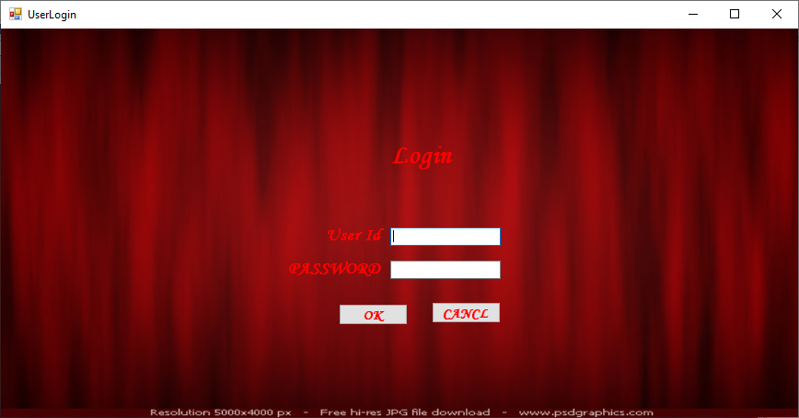



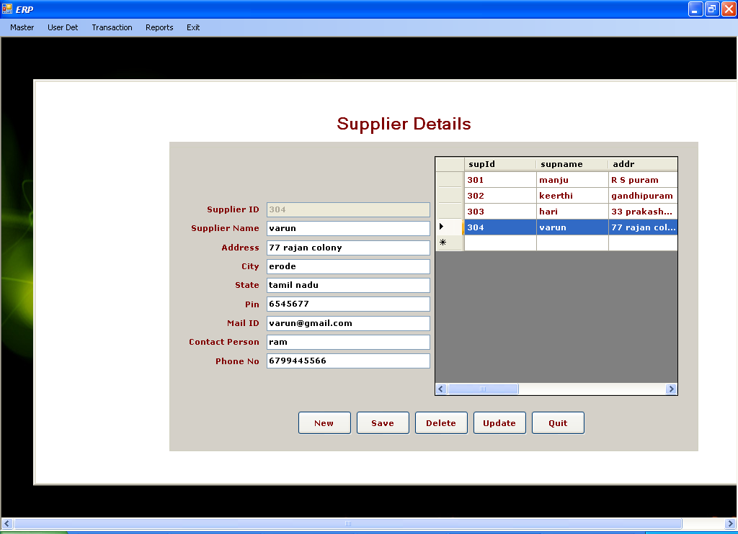

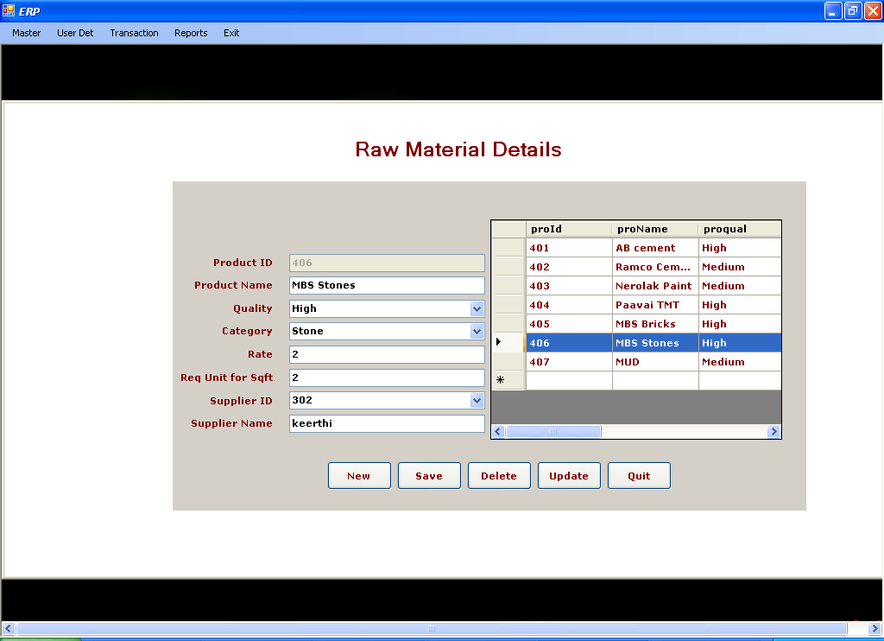

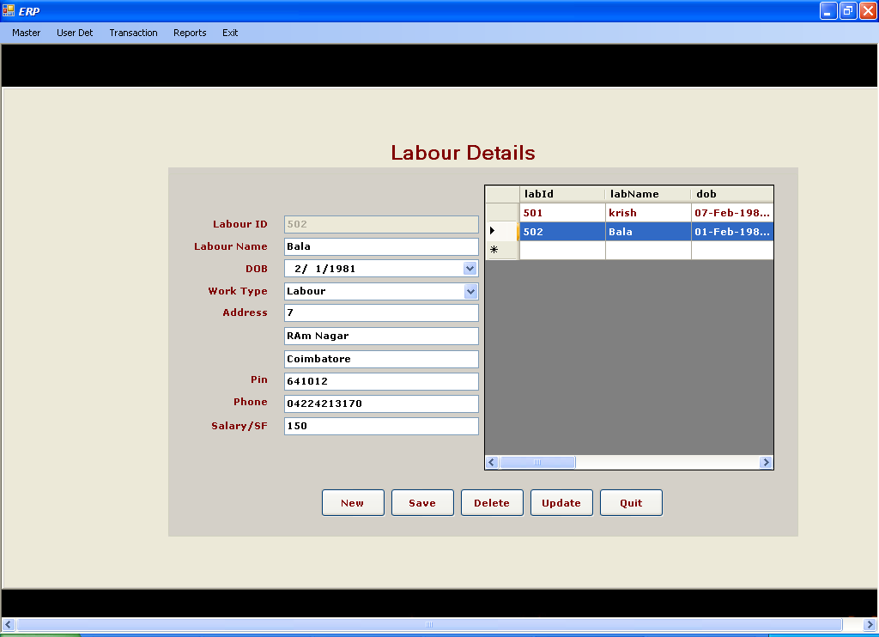

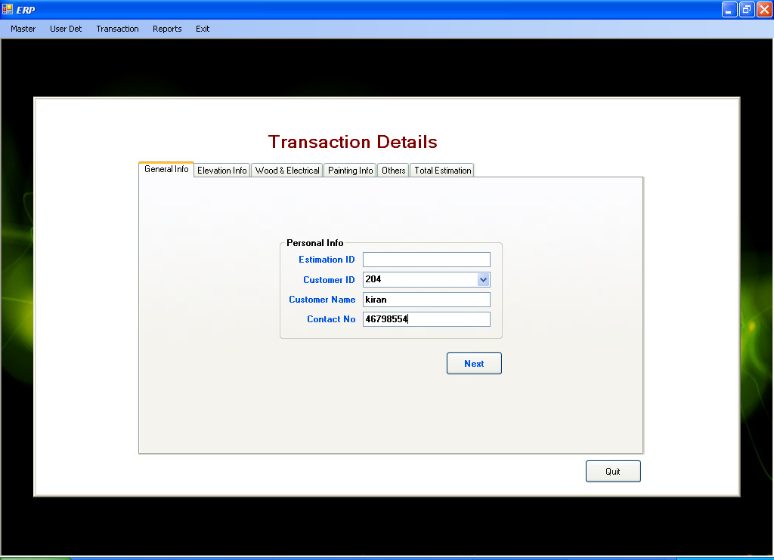

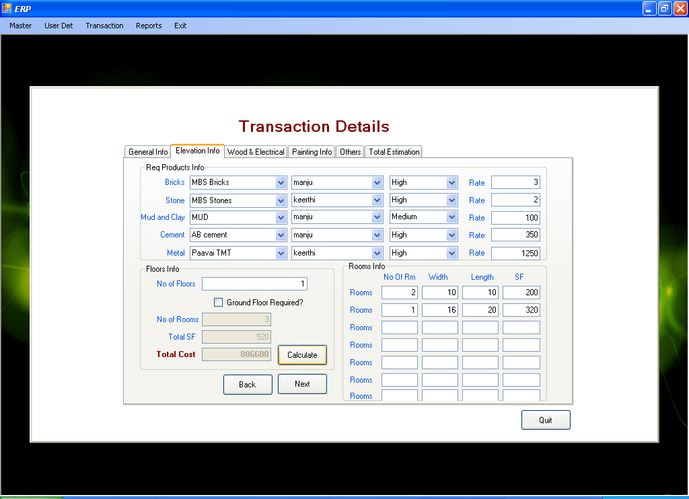

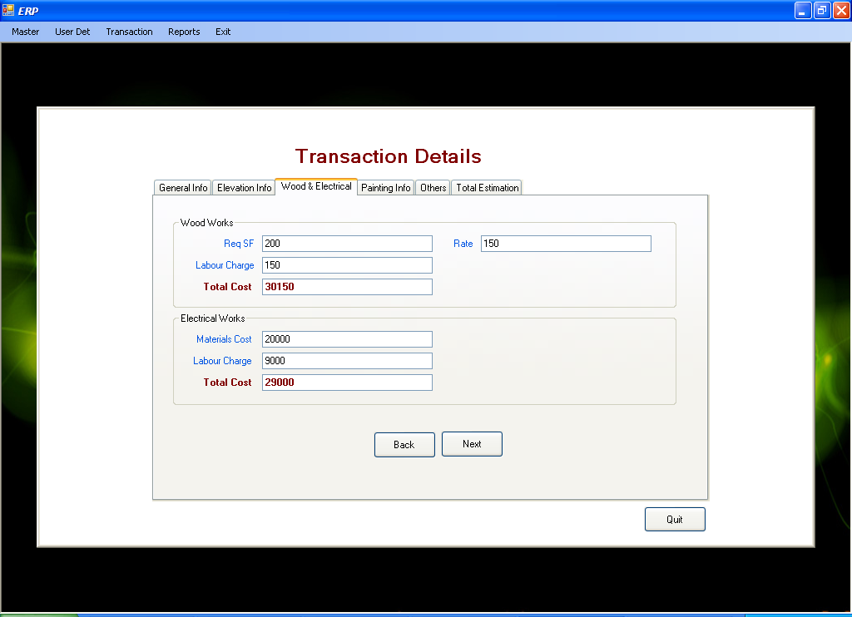

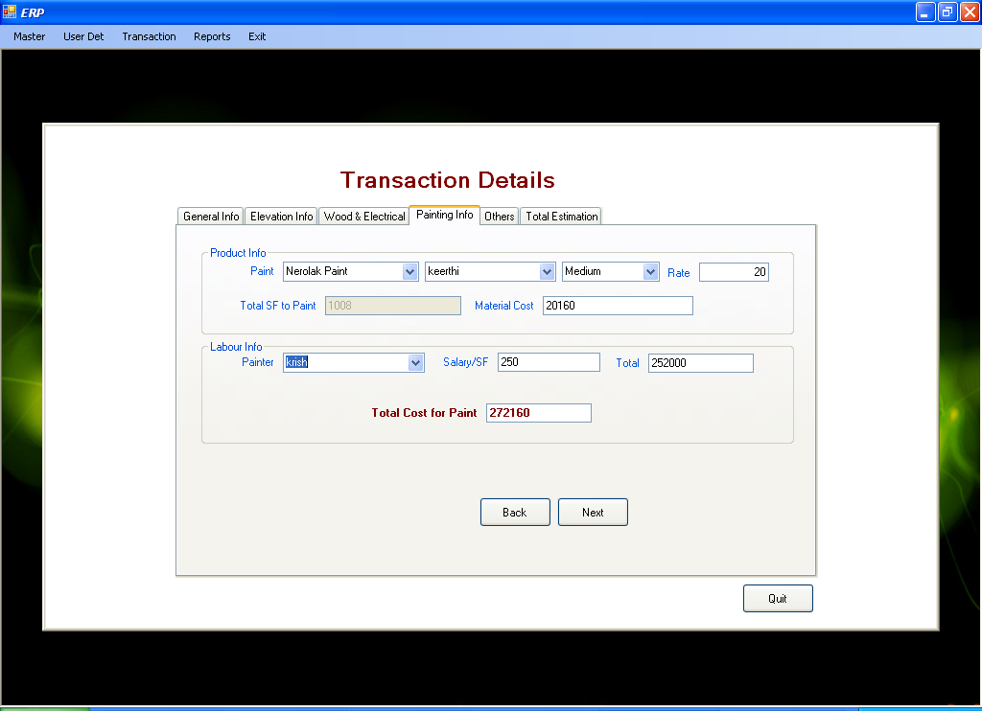

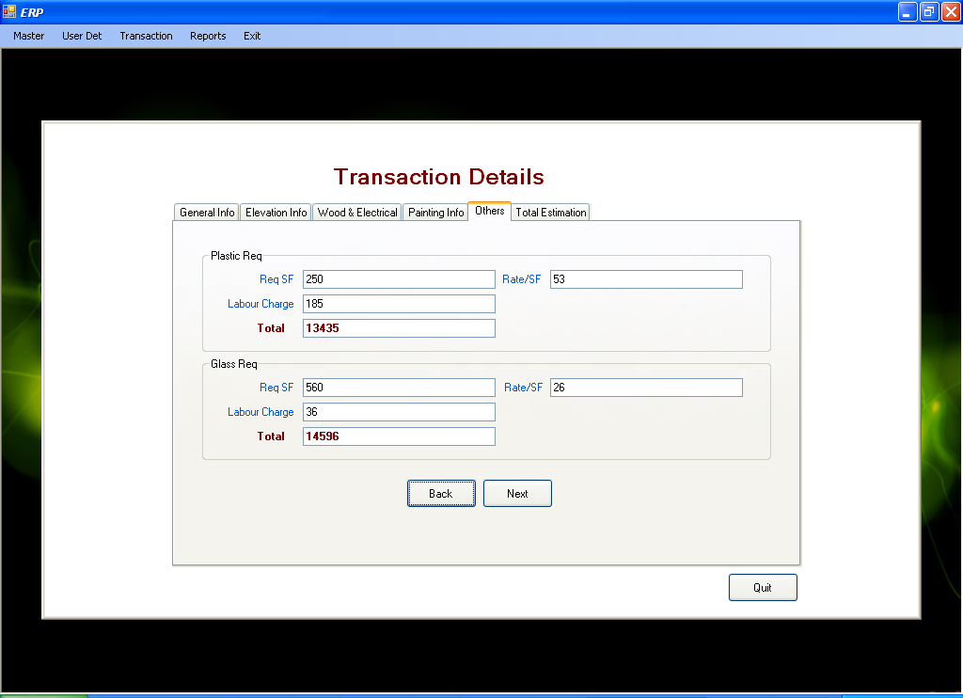

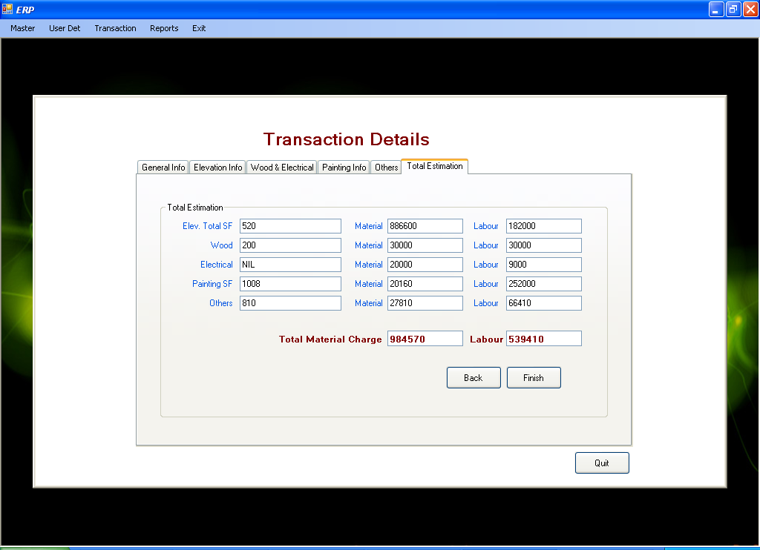





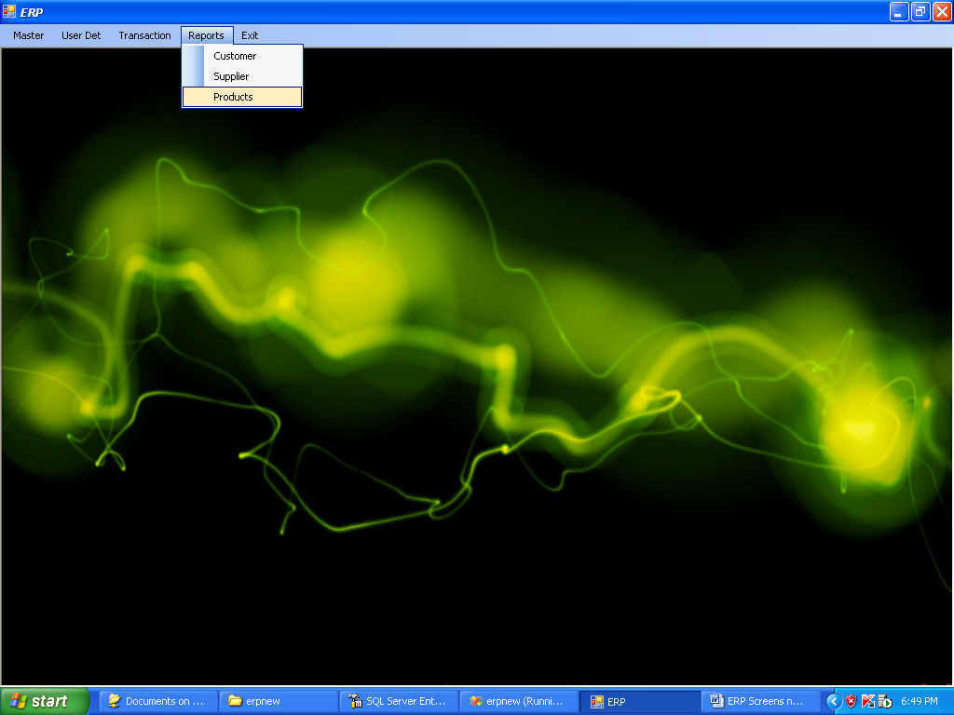

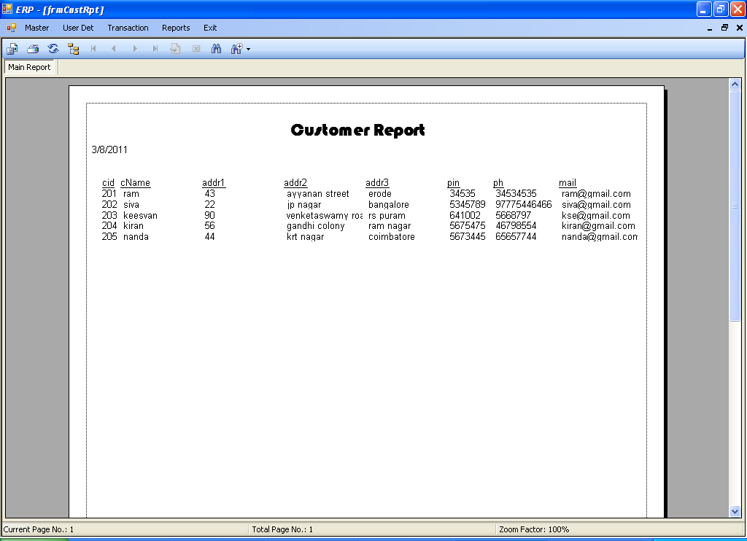

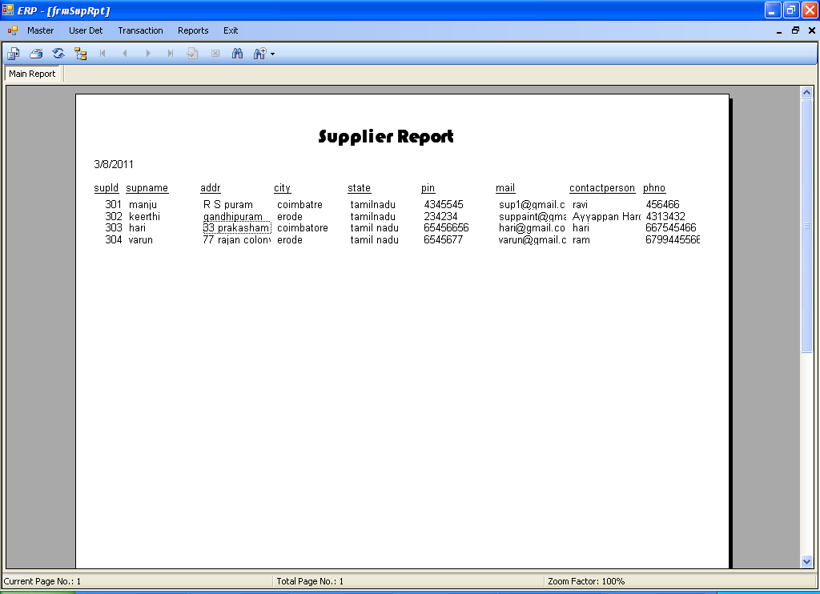

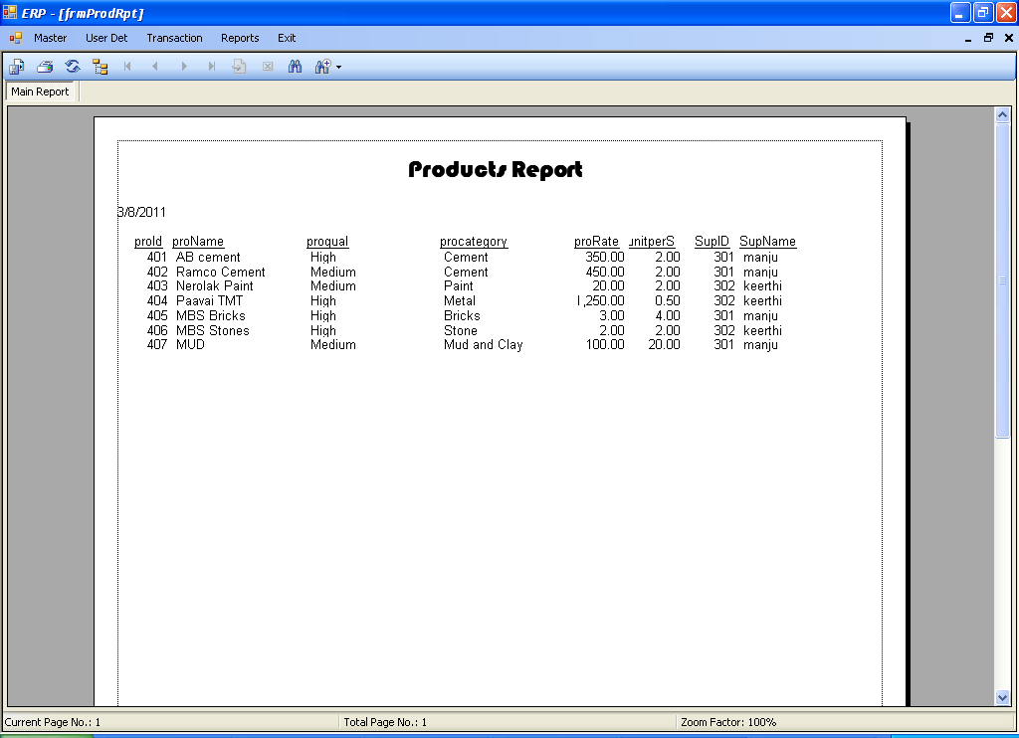

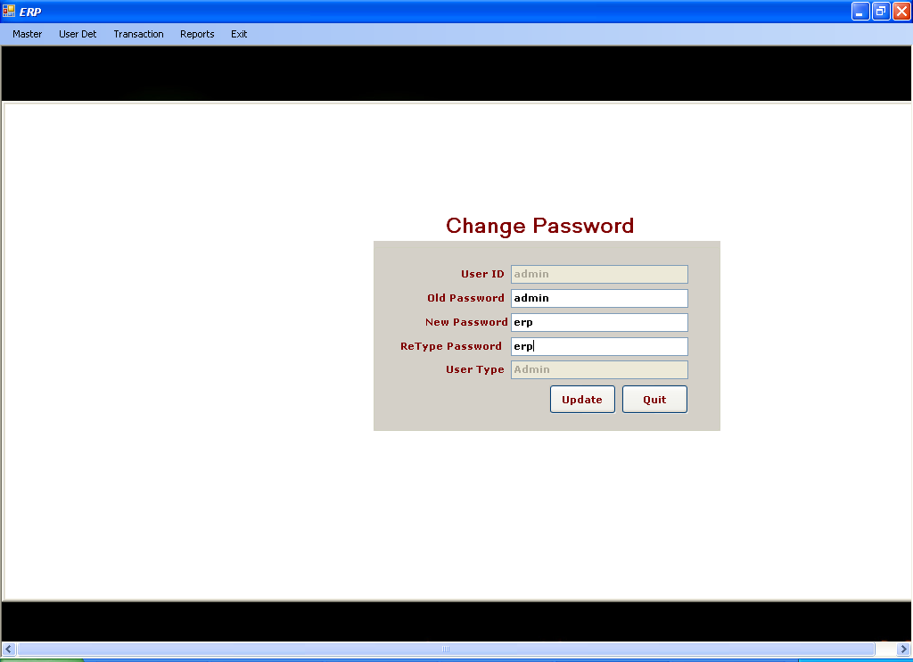

Sample Coding

Login

Imports System.Data.SqlClient

Public Class Login

Private Sub Button1_Click(ByVal sender As System.Object, ByVal e As System.EventArgs) Handles Button1.Click
If cn.State = ConnectionState.Closed Then cn.Open()
cmd = New SqlCommand("SELECT * FROM logDet WHERE uid = '" & TextBox1.Text & "' and pass='" & TextBox2.Text & "'", cn)
Dim dr As SqlDataReader = cmd.ExecuteReader
If dr.Read Then
uName = dr(0)
uType = dr(2)
MsgBox("Welcome " & TextBox1.Text & "")

Dim frm As New frmMain
frm.Show()
Me.Hide()
Else
MsgBox("Invalid User ID ! Please Try Again")
End If
cn.Close()

End Sub

Private Sub Button2_Click(ByVal sender As System.Object, ByVal e As System.EventArgs) Handles Button2.Click
End
End Sub
End Class

Adduser

Imports System.Data.SqlClient
Public Class frmAddUser
Private Sub Button5_Click(ByVal sender As System.Object, ByVal e As System.EventArgs) Handles Button5.Click
Me.Close()
End Sub

Private Sub Button1_Click(ByVal sender As System.Object, ByVal e As System.EventArgs) Handles Button1.Click
TextBox1.Text = ""
TextBox2.Text = ""
TextBox3.Text = ""
ComboBox1.Text = ""
End Sub

Private Sub Button2_Click(ByVal sender As System.Object, ByVal e As System.EventArgs) Handles Button2.Click
Try
If cn.State = ConnectionState.Closed Then cn.Open()
If TextBox2.Text = TextBox3.Text Then
cmd = New SqlCommand("insert into logDet values('" & TextBox1.Text & "','" & TextBox2.Text & "','" & ComboBox1.Text & "')", cn)
cmd.ExecuteNonQuery()
MsgBox("Successfully Saved", MsgBoxStyle.Exclamation)
Else
MsgBox("Password Miss Match", MsgBoxStyle.Critical)
End If

cn.Close()
Catch ex As Exception
MsgBox(ex.Message, MsgBoxStyle.Critical)
End Try
fillgrid()

End Sub
Private Sub fillgrid()
Dim da As New SqlDataAdapter("select * from logDet", cn)
If cn.State = ConnectionState.Closed Then cn.Open()
Dim ds As New DataSet
da.Fill(ds)
DataGridView1.DataSource = ds.Tables(0)
cn.Close()
End Sub
Private Sub frmEmployee_Load(ByVal sender As System.Object, ByVal e As System.EventArgs) Handles MyBase.Load
fillgrid()
Button1_Click(sender, e)
End Sub

Private Sub Button3_Click(ByVal sender As System.Object, ByVal e As System.EventArgs) Handles Button3.Click
Try
Dim i As String = InputBox("Enter User ID to Delete", "Delete")
If cn.State = ConnectionState.Closed Then cn.Open()
cmd = New SqlCommand("delete from logDet where uid='" & i & "'", cn)
cmd.ExecuteNonQuery()
MsgBox("Deleted Successfully", MsgBoxStyle.Exclamation)
cn.Close()
fillgrid()
Catch ex As Exception
MsgBox(ex.Message, MsgBoxStyle.Critical)
End Try

End Sub
Dim iId As String
Private Sub DataGridView1_CellClick(ByVal sender As Object, ByVal e As System.Windows.Forms.DataGridViewCellEventArgs) Handles DataGridView1.CellClick

iId = DataGridView1.Rows(e.RowIndex).Cells(0).Value
Try
If cn.State = ConnectionState.Closed Then cn.Open()
cmd = New SqlCommand("select * from logDet where uid='" & iId & "'", cn)
Dim dr As SqlDataReader
dr = cmd.ExecuteReader
If dr.Read Then
TextBox1.Text = dr(0)
TextBox2.Text = dr(1)
ComboBox1.Text = dr(2)
End If
cn.Close()
Catch ex As Exception
MsgBox(ex.Message, MsgBoxStyle.Critical)
End Try

End Sub

Private Sub Button4_Click(ByVal sender As System.Object, ByVal e As System.EventArgs) Handles Button4.Click
Try
If cn.State = ConnectionState.Closed Then cn.Open()
cmd = New SqlCommand("update logDet set pass='" & TextBox2.Text & "', utype='" & ComboBox1.Text & "' where uid=" & iId & "", cn)
cmd.ExecuteNonQuery()
MsgBox("Data are Successfully Updated", MsgBoxStyle.Exclamation)
cn.Close()
Catch ex As Exception
MsgBox(ex.Message, MsgBoxStyle.Critical)
End Try
fillgrid()
End Sub
End Class

ChangePassword

Imports System.Data.SqlClient
Public Class frmChangePwd

Private Sub Button5_Click(ByVal sender As System.Object, ByVal e As System.EventArgs) Handles Button5.Click
Me.Close()

End Sub

Private Sub Button4_Click(ByVal sender As System.Object, ByVal e As System.EventArgs) Handles Button4.Click
Try
If TextBox3.Text = TextBox4.Text Then
If cn.State = ConnectionState.Closed Then cn.Open()
cmd = New SqlCommand("select * from logdet where uid= '" & TextBox1.Text & "' and pass='" & TextBox2.Text & "'", cn)
Dim dr As SqlDataReader = cmd.ExecuteReader
If dr.Read Then
dr.Close()
cmd = New SqlCommand("update logdet set pass='" & TextBox3.Text & "' where uid= '" & TextBox1.Text & "' and pass='" & TextBox2.Text & "'", cn)
cmd.ExecuteNonQuery()
MsgBox("Password Changed Successfully")

Else
MsgBox("Old Password is Wrong")
End If
cn.Close()
Else
MsgBox("Retype Password Mismatch")
End If

Catch ex As Exception
MsgBox(ex.Message, MsgBoxStyle.Critical)
End Try

End Sub

Private Sub frmChangePwd_Load(ByVal sender As System.Object, ByVal e As System.EventArgs) Handles MyBase.Load
TextBox1.Enabled = False
TextBox1.Text = uName
TextBox5.Text = uType
End Sub
End Class

Customer

Imports System.Data.SqlClient
Public Class frmCustomer

Private Sub Button5_Click(ByVal sender As System.Object, ByVal e As System.EventArgs) Handles Button5.Click
Me.Close()
End Sub

Private Sub Button1_Click(ByVal sender As System.Object, ByVal e As System.EventArgs) Handles Button1.Click
TextBox1.Text = ""
TextBox1.Enabled = False
If cn.State = ConnectionState.Closed Then cn.Open()
cmd = New SqlCommand("select max(cid) from cust", cn)
Dim i As Integer = IIf(IsDBNull(cmd.ExecuteScalar), 0, cmd.ExecuteScalar)
TextBox1.Text = i + 1
TextBox2.Text = ""
TextBox8.Text = ""
TextBox9.Text = ""
TextBox10.Text = ""
TextBox11.Text = ""
TextBox12.Text = ""
TextBox13.Text = ""
End Sub

Private Sub Button2_Click(ByVal sender As System.Object, ByVal e As System.EventArgs) Handles Button2.Click
Try
If cn.State = ConnectionState.Closed Then cn.Open()
cmd = New SqlCommand("insert into cust values('" & TextBox2.Text & "','" & TextBox8.Text & "','" & TextBox9.Text & "','" & TextBox10.Text & "'," & TextBox11.Text & ",'" & TextBox12.Text & "','" & TextBox13.Text & "')", cn)
cmd.ExecuteNonQuery()
MsgBox("Successfully Saved", MsgBoxStyle.Exclamation)
cn.Close()
Catch ex As Exception
MsgBox(ex.Message, MsgBoxStyle.Critical)
End Try
fillgrid()

End Sub
Private Sub fillgrid()
Dim da As New SqlDataAdapter("select * from cust", cn)
If cn.State = ConnectionState.Closed Then cn.Open()
Dim ds As New DataSet
da.Fill(ds)
DataGridView1.DataSource = ds.Tables(0)
cn.Close()
End Sub
Private Sub frmEmployee_Load(ByVal sender As System.Object, ByVal e As System.EventArgs) Handles MyBase.Load
fillgrid()
Button1_Click(sender, e)
End Sub

Private Sub Button3_Click(ByVal sender As System.Object, ByVal e As System.EventArgs) Handles Button3.Click
Try
Dim i As Integer = InputBox("Enter Emp Id to Delete", "Delete")
If cn.State = ConnectionState.Closed Then cn.Open()
cmd = New SqlCommand("delete from cust where cid=" & i & "", cn)
cmd.ExecuteNonQuery()
MsgBox("Deleted Successfully", MsgBoxStyle.Exclamation)
cn.Close()
fillgrid()
Catch ex As Exception
MsgBox(ex.Message, MsgBoxStyle.Critical)
End Try

End Sub
Dim iId As Integer
Private Sub DataGridView1_CellClick(ByVal sender As Object, ByVal e As System.Windows.Forms.DataGridViewCellEventArgs) Handles DataGridView1.CellClick

iId = Convert.ToInt32(DataGridView1.Rows(e.RowIndex).Cells(0).Value)
Try
If cn.State = ConnectionState.Closed Then cn.Open()
cmd = New SqlCommand("select * from cust where cid=" & iId & "", cn)
Dim dr As SqlDataReader
dr = cmd.ExecuteReader
If dr.Read Then
TextBox1.Text = dr(0)
TextBox2.Text = dr(1)
TextBox8.Text = dr(2)
TextBox9.Text = dr(3)
TextBox10.Text = dr(4)
TextBox11.Text = dr(5)
TextBox12.Text = dr(6)
TextBox13.Text = dr(7)
End If
cn.Close()
Catch ex As Exception
MsgBox(ex.Message, MsgBoxStyle.Critical)
End Try

End Sub

Private Sub Button4_Click(ByVal sender As System.Object, ByVal e As System.EventArgs) Handles Button4.Click
Try
If cn.State = ConnectionState.Closed Then cn.Open()
cmd = New SqlCommand("update cust set cname='" & TextBox2.Text & "',addr1='" & TextBox8.Text & "',addr2='" & TextBox9.Text & "',addr3='" & TextBox10.Text & "',pin=" & TextBox11.Text & ",ph='" & TextBox12.Text & "',mail='" & TextBox13.Text & "' where cid=" & iId & "", cn)
cmd.ExecuteNonQuery()
MsgBox("Data are Successfully Updated", MsgBoxStyle.Exclamation)
cn.Close()
Catch ex As Exception
MsgBox(ex.Message, MsgBoxStyle.Critical)
End Try
fillgrid()
End Sub
End Class

Employee

Imports System.Data.SqlClient

Public Class frmEmployee

Private Sub Button5_Click(ByVal sender As System.Object, ByVal e As System.EventArgs) Handles Button5.Click
Me.Close()
End Sub

Private Sub Button1_Click(ByVal sender As System.Object, ByVal e As System.EventArgs) Handles Button1.Click
TextBox1.Text = ""
TextBox1.Enabled = False
If cn.State = ConnectionState.Closed Then cn.Open()
cmd = New SqlCommand("select max(eid) from emp", cn)
Dim i As Integer = IIf(IsDBNull(cmd.ExecuteScalar), 0, cmd.ExecuteScalar) + 1
TextBox1.Text = i
TextBox2.Text = ""
TextBox4.Text = ""
TextBox5.Text = ""
TextBox6.Text = ""
TextBox8.Text = ""
TextBox9.Text = ""
TextBox10.Text = ""
TextBox11.Text = ""
TextBox12.Text = ""
TextBox13.Text = ""
End Sub

Private Sub Button2_Click(ByVal sender As System.Object, ByVal e As System.EventArgs) Handles Button2.Click
Try
If cn.State = ConnectionState.Closed Then cn.Open()
cmd = New SqlCommand("insert into emp values('" & TextBox2.Text & "','" & DateTimePicker1.Value & "','" & TextBox4.Text & "','" & TextBox5.Text & "','" & TextBox6.Text & "','" & DateTimePicker2.Value & "','" & TextBox8.Text & "','" & TextBox9.Text & "','" & TextBox10.Text & "'," & TextBox11.Text & ",'" & TextBox12.Text & "','" & TextBox13.Text & "')", cn)
cmd.ExecuteNonQuery()
MsgBox("Successfully Saved", MsgBoxStyle.Exclamation)
cn.Close()
Catch ex As Exception
MsgBox(ex.Message, MsgBoxStyle.Critical)
End Try
fillgrid()

End Sub
Private Sub fillgrid()
Dim da As New SqlDataAdapter("select * from emp", cn)
If cn.State = ConnectionState.Closed Then cn.Open()
Dim ds As New DataSet
da.Fill(ds)
DataGridView1.DataSource = ds.Tables(0)
cn.Close()
End Sub
Private Sub frmEmployee_Load(ByVal sender As System.Object, ByVal e As System.EventArgs) Handles MyBase.Load
fillgrid()
Button1_Click(sender, e)
End Sub

Private Sub Button3_Click(ByVal sender As System.Object, ByVal e As System.EventArgs) Handles Button3.Click
Try
Dim i As Integer = InputBox("Enter Emp Id to Delete", "Delete")
If cn.State = ConnectionState.Closed Then cn.Open()
cmd = New SqlCommand("delete from emp where eid=" & i & "", cn)
cmd.ExecuteNonQuery()
MsgBox("Deleted Successfully", MsgBoxStyle.Exclamation)
cn.Close()
fillgrid()
Catch ex As Exception
MsgBox(ex.Message, MsgBoxStyle.Critical)
End Try

End Sub
Dim iId As Integer
Private Sub DataGridView1_CellClick(ByVal sender As Object, ByVal e As System.Windows.Forms.DataGridViewCellEventArgs) Handles DataGridView1.CellClick

iId = Convert.ToInt32(DataGridView1.Rows(e.RowIndex).Cells(0).Value)
Try
If cn.State = ConnectionState.Closed Then cn.Open()
cmd = New SqlCommand("select * from emp where eid=" & iId & "", cn)
Dim dr As SqlDataReader
dr = cmd.ExecuteReader
If dr.Read Then
TextBox1.Text = dr(0)
TextBox2.Text = dr(1)
DateTimePicker1.Value = dr(2)
TextBox4.Text = dr(3)
TextBox5.Text = dr(4)
TextBox6.Text = dr(5)
DateTimePicker1.Value = dr(6)
TextBox8.Text = dr(7)
TextBox9.Text = dr(8)
TextBox10.Text = dr(9)
TextBox11.Text = dr(10)
TextBox12.Text = dr(11)
TextBox13.Text = dr(12)
End If
cn.Close()
Catch ex As Exception
MsgBox(ex.Message, MsgBoxStyle.Critical)
End Try

End Sub

Private Sub Button4_Click(ByVal sender As System.Object, ByVal e As System.EventArgs) Handles Button4.Click
Try
If cn.State = ConnectionState.Closed Then cn.Open()
cmd = New SqlCommand("update emp set name='" & TextBox2.Text & "', dob='" & DateTimePicker1.Value & "',qft='" & TextBox4.Text & "',exp='" & TextBox5.Text & "',design='" & TextBox6.Text & "',doj='" & DateTimePicker2.Value & "',addr1='" & TextBox8.Text & "',addr2='" & TextBox9.Text & "',addr3='" & TextBox10.Text & "',pin=" & TextBox11.Text & ",ph='" & TextBox12.Text & "',mail='" & TextBox13.Text & "' where eid=" & iId & "", cn)
cmd.ExecuteNonQuery()
MsgBox("Data are Successfully Updated", MsgBoxStyle.Exclamation)
cn.Close()
Catch ex As Exception
MsgBox(ex.Message, MsgBoxStyle.Critical)
End Try
fillgrid()
End Sub

Private Sub DataGridView1_CellContentClick(ByVal sender As System.Object, ByVal e As System.Windows.Forms.DataGridViewCellEventArgs) Handles DataGridView1.CellContentClick

End Sub
End Class

Labour

Imports System.Data.SqlClient
Public Class frmLabour

Private Sub Button5_Click(ByVal sender As System.Object, ByVal e As System.EventArgs) Handles Button5.Click
Me.Close()
End Sub

Private Sub Button1_Click(ByVal sender As System.Object, ByVal e As System.EventArgs) Handles Button1.Click
TextBox1.Text = ""
TextBox1.Enabled = False
If cn.State = ConnectionState.Closed Then cn.Open()
cmd = New SqlCommand("select max(labId) from labDetails", cn)
Dim i As Integer = IIf(IsDBNull(cmd.ExecuteScalar), 0, cmd.ExecuteScalar) + 1
TextBox1.Text = i
TextBox2.Text = ""
ComboBox1.Text = ""
TextBox3.Text = ""
TextBox4.Text = ""
TextBox5.Text = ""
TextBox6.Text = ""
TextBox7.Text = ""
TextBox8.Text = ""
End Sub

Private Sub Button2_Click(ByVal sender As System.Object, ByVal e As System.EventArgs) Handles Button2.Click
Try
If cn.State = ConnectionState.Closed Then cn.Open()
cmd = New SqlCommand("insert into labDetails values('" & TextBox2.Text & "','" & DateTimePicker1.Value & "','" & ComboBox1.Text & "','" & TextBox3.Text & "','" & TextBox4.Text & "','" & TextBox5.Text & "','" & TextBox6.Text & "','" & TextBox7.Text & "'," & TextBox8.Text & ")", cn)
cmd.ExecuteNonQuery()
MsgBox("Successfully Saved", MsgBoxStyle.Exclamation)
cn.Close()
Catch ex As Exception
MsgBox(ex.Message, MsgBoxStyle.Critical)
End Try
fillgrid()

End Sub
Private Sub fillgrid()
Dim da As New SqlDataAdapter("select * from labDetails", cn)
If cn.State = ConnectionState.Closed Then cn.Open()
Dim ds As New DataSet
da.Fill(ds)
DataGridView1.DataSource = ds.Tables(0)
cn.Close()
End Sub
Private Sub frmEmployee_Load(ByVal sender As System.Object, ByVal e As System.EventArgs) Handles MyBase.Load
fillgrid()
Button1_Click(sender, e)
End Sub

Private Sub Button3_Click(ByVal sender As System.Object, ByVal e As System.EventArgs) Handles Button3.Click
Try
Dim i As Integer = InputBox("Enter Labour Id to Delete", "Delete")
If cn.State = ConnectionState.Closed Then cn.Open()
cmd = New SqlCommand("delete from labDetails where labid=" & i & "", cn)
cmd.ExecuteNonQuery()
MsgBox("Deleted Successfully", MsgBoxStyle.Exclamation)
cn.Close()
fillgrid()
Catch ex As Exception
MsgBox(ex.Message, MsgBoxStyle.Critical)
End Try

End Sub
Dim iId As Integer
Private Sub DataGridView1_CellClick(ByVal sender As Object, ByVal e As System.Windows.Forms.DataGridViewCellEventArgs) Handles DataGridView1.CellClick

iId = Convert.ToInt32(DataGridView1.Rows(e.RowIndex).Cells(0).Value)
Try
If cn.State = ConnectionState.Closed Then cn.Open()
cmd = New SqlCommand("select * from labDetails where labid=" & iId & "", cn)
Dim dr As SqlDataReader
dr = cmd.ExecuteReader
If dr.Read Then
TextBox1.Text = dr(0)
TextBox2.Text = dr(1)
DateTimePicker1.Value = dr(2)
ComboBox1.Text = dr(3)
TextBox3.Text = dr(4)
TextBox4.Text = dr(5)
TextBox5.Text = dr(6)
TextBox6.Text = dr(7)
TextBox7.Text = dr(8)
TextBox8.Text = dr(9)
End If
cn.Close()
Catch ex As Exception
MsgBox(ex.Message, MsgBoxStyle.Critical)
End Try

End Sub

Private Sub Button4_Click(ByVal sender As System.Object, ByVal e As System.EventArgs) Handles Button4.Click
Try
If cn.State = ConnectionState.Closed Then cn.Open()
cmd = New SqlCommand("update labDetails set labname='" & TextBox2.Text & "', dob='" & DateTimePicker1.Value & "',worktype='" & ComboBox1.Text & "',labadd1='" & TextBox3.Text & "',labadd2='" & TextBox4.Text & "',labadd3='" & TextBox5.Text & "',pin=" & TextBox6.Text & ",ph='" & TextBox7.Text & "',salsft=" & TextBox8.Text & " where labid=" & iId & "", cn)
cmd.ExecuteNonQuery()
MsgBox("Data are Successfully Updated", MsgBoxStyle.Exclamation)
cn.Close()
Catch ex As Exception
MsgBox(ex.Message, MsgBoxStyle.Critical)
End Try
fillgrid()
End Sub
End Class

Transactions

Imports System.Data.SqlClient

Public Class frmTrans

'Private Sub TextBox33_GotFocus(ByVal sender As Object, ByVal e As System.EventArgs) Handles TextBox33.GotFocus
' TextBox33.Text = Val(TextBox31.Text) * Val(ComboBox11.SelectedItem)

'End Sub

'Private Sub TextBox36_GotFocus(ByVal sender As Object, ByVal e As System.EventArgs) Handles TextBox36.GotFocus
' TextBox36.Text = Val(TextBox34.Text) * Val(TextBox35.Text)

'End Sub

Private Sub frmTrans_Load(ByVal sender As System.Object, ByVal e As System.EventArgs) Handles MyBase.Load
Try
If cn.State = ConnectionState.Closed Then cn.Open()
cmd = New SqlCommand("select * from cust", cn)
Dim dr As SqlDataReader
dr = cmd.ExecuteReader
While dr.Read
ComboBox1.Items.Add(dr(0))
End While
dr.Close()

cmd = New SqlCommand("select * from prod", cn)
Dim dr1 As SqlDataReader
dr1 = cmd.ExecuteReader
While dr1.Read
If dr1(3).ToString = "Bricks" Then
ComboBox2.Items.Add(dr1(1))
ComboBox7.Items.Add(dr1(7))
ComboBox14.Items.Add(dr1(2))
ElseIf dr1(3).ToString = "Stone" Then
ComboBox3.Items.Add(dr1(1))
ComboBox8.Items.Add(dr1(7))
ComboBox15.Items.Add(dr1(2))
ElseIf dr1(3).ToString = "Mud and Clay" Then
ComboBox4.Items.Add(dr1(1))
ComboBox9.Items.Add(dr1(7))
ComboBox16.Items.Add(dr1(2))
ElseIf dr1(3).ToString = "Cement" Then
ComboBox5.Items.Add(dr1(1))
ComboBox10.Items.Add(dr1(7))
ComboBox17.Items.Add(dr1(2))
ElseIf dr1(3).ToString = "Metal" Then
ComboBox12.Items.Add(dr1(1))
ComboBox13.Items.Add(dr1(7))
ComboBox18.Items.Add(dr1(2))
ElseIf dr1(3).ToString = "Paint" Then
ComboBox6.Items.Add(dr1(1))
ComboBox20.Items.Add(dr1(7))
ComboBox19.Items.Add(dr1(2))
End If

End While
dr1.Close()

cmd = New SqlCommand("select * from labdetails", cn)
Dim dr2 As SqlDataReader
dr2 = cmd.ExecuteReader
While dr2.Read
If dr2(3) = "Painter" Then
ComboBox11.Items.Add(dr2(1))
End If

End While
dr2.Close()

cn.Close()
Catch ex As Exception
MsgBox(ex.Message, MsgBoxStyle.Critical)
End Try

End Sub

Private Sub ComboBox1_SelectedIndexChanged(ByVal sender As System.Object, ByVal e As System.EventArgs) Handles ComboBox1.SelectedIndexChanged
Try
If cn.State = ConnectionState.Closed Then cn.Open()
cmd = New SqlCommand("select * from cust where cid=" & ComboBox1.Text & "", cn)
Dim dr As SqlDataReader
dr = cmd.ExecuteReader
If dr.Read Then
TextBox2.Text = dr(1)
TextBox3.Text = dr(6)
End If
dr.Close()
cn.Close()
Catch ex As Exception
MsgBox(ex.Message, MsgBoxStyle.Critical)
End Try

End Sub

Private Sub Button1_Click(ByVal sender As System.Object, ByVal e As System.EventArgs) Handles Button1.Click
Me.Close()
End Sub

Private Sub Button2_Click(ByVal sender As System.Object, ByVal e As System.EventArgs) Handles Button2.Click
TabControl1.SelectedIndex = TabControl1.SelectedIndex + 1
End Sub

Private Sub Button4_Click(ByVal sender As System.Object, ByVal e As System.EventArgs) Handles Button4.Click
TabControl1.SelectedIndex = TabControl1.SelectedIndex + 1
End Sub

Private Sub Button7_Click(ByVal sender As System.Object, ByVal e As System.EventArgs) Handles Button7.Click
TabControl1.SelectedIndex = TabControl1.SelectedIndex + 1
End Sub

Private Sub Button10_Click(ByVal sender As System.Object, ByVal e As System.EventArgs) Handles Button10.Click
TabControl1.SelectedIndex = TabControl1.SelectedIndex + 1
End Sub

Private Sub Button11_Click(ByVal sender As System.Object, ByVal e As System.EventArgs) Handles Button11.Click
TabControl1.SelectedIndex = TabControl1.SelectedIndex + 1
End Sub

Private Sub Button5_Click(ByVal sender As System.Object, ByVal e As System.EventArgs) Handles Button5.Click
TabControl1.SelectedIndex = TabControl1.SelectedIndex - 1
End Sub

Private Sub Button6_Click(ByVal sender As System.Object, ByVal e As System.EventArgs) Handles Button6.Click
TabControl1.SelectedIndex = TabControl1.SelectedIndex - 1
End Sub

Private Sub Button9_Click(ByVal sender As System.Object, ByVal e As System.EventArgs) Handles Button9.Click
TabControl1.SelectedIndex = TabControl1.SelectedIndex - 1
End Sub

Private Sub Button12_Click(ByVal sender As System.Object, ByVal e As System.EventArgs) Handles Button12.Click
TabControl1.SelectedIndex = TabControl1.SelectedIndex - 1
End Sub

Private Sub Button14_Click(ByVal sender As System.Object, ByVal e As System.EventArgs) Handles Button14.Click
TabControl1.SelectedIndex = TabControl1.SelectedIndex - 1
End Sub

Private Sub ComboBox8_SelectedIndexChanged(ByVal sender As System.Object, ByVal e As System.EventArgs) Handles ComboBox8.SelectedIndexChanged, ComboBox15.SelectedIndexChanged
TextBox13.Text = getRate(ComboBox3.Text, ComboBox8.Text, ComboBox15.Text)
End Sub

Private Sub ComboBox14_SelectedIndexChanged(ByVal sender As System.Object, ByVal e As System.EventArgs) Handles ComboBox14.SelectedIndexChanged
TextBox12.Text = getRate(ComboBox2.Text, ComboBox7.Text, ComboBox14.Text)
End Sub

Private Function getRate(ByVal pName As String, ByVal sup As String, ByVal qual As String) As Integer
Dim iRate As Integer
Try
If cn.State = ConnectionState.Closed Then cn.Open()
cmd = New SqlCommand("select prorate from prod where proname='" & pName & "' and supname='" & sup & "' and proqual='" & qual & "'", cn)
iRate = cmd.ExecuteScalar
If iRate = 0 Then
MsgBox("No Product Quality Found")
End If

cn.Close()
Return iRate
Catch ex As Exception
MsgBox(ex.Message, MsgBoxStyle.Critical)
End Try
End Function

Private Sub ComboBox17_SelectedIndexChanged(ByVal sender As System.Object, ByVal e As System.EventArgs) Handles ComboBox17.SelectedIndexChanged
TextBox15.Text = getRate(ComboBox5.Text, ComboBox10.Text, ComboBox17.Text)
End Sub

Private Sub ComboBox16_SelectedIndexChanged(ByVal sender As System.Object, ByVal e As System.EventArgs) Handles ComboBox16.SelectedIndexChanged
TextBox14.Text = getRate(ComboBox4.Text, ComboBox9.Text, ComboBox16.Text)
End Sub

Private Sub ComboBox18_SelectedIndexChanged(ByVal sender As System.Object, ByVal e As System.EventArgs) Handles ComboBox18.SelectedIndexChanged
TextBox37.Text = getRate(ComboBox12.Text, ComboBox13.Text, ComboBox18.Text)
End Sub

Private Sub TextBox18_TextChanged(ByVal sender As System.Object, ByVal e As System.EventArgs) Handles TextBox18.TextChanged
TextBox47.Text = Val(TextBox6.Text) * Val(TextBox68.Text) * Val(TextBox18.Text)
End Sub

Private Sub TextBox17_TextChanged(ByVal sender As System.Object, ByVal e As System.EventArgs) Handles TextBox17.TextChanged
TextBox46.Text = Val(TextBox7.Text) * Val(TextBox67.Text) * Val(TextBox17.Text)
End Sub

Private Sub TextBox21_TextChanged(ByVal sender As System.Object, ByVal e As System.EventArgs) Handles TextBox21.TextChanged
TextBox50.Text = Val(TextBox8.Text) * Val(TextBox71.Text) * Val(TextBox21.Text)
End Sub

Private Sub TextBox20_TextChanged(ByVal sender As System.Object, ByVal e As System.EventArgs) Handles TextBox20.TextChanged
TextBox49.Text = Val(TextBox10.Text) * Val(TextBox70.Text) * Val(TextBox20.Text)
End Sub

Private Sub TextBox19_TextChanged(ByVal sender As System.Object, ByVal e As System.EventArgs) Handles TextBox19.TextChanged
TextBox48.Text = Val(TextBox9.Text) * Val(TextBox69.Text) * Val(TextBox19.Text)
End Sub

Private Sub TextBox22_TextChanged(ByVal sender As System.Object, ByVal e As System.EventArgs) Handles TextBox22.TextChanged
TextBox51.Text = Val(TextBox11.Text) * Val(TextBox72.Text) * Val(TextBox22.Text)
End Sub

Private Sub TextBox23_TextChanged(ByVal sender As System.Object, ByVal e As System.EventArgs) Handles TextBox23.TextChanged
TextBox52.Text = Val(TextBox16.Text) * Val(TextBox73.Text) * Val(TextBox23.Text)
End Sub
Dim iTotWidth, iTotLength As Integer

Private Sub Button3_Click(ByVal sender As System.Object, ByVal e As System.EventArgs) Handles Button3.Click
TextBox24.Text = Val(TextBox47.Text) + Val(TextBox46.Text) + Val(TextBox50.Text) + Val(TextBox49.Text) + Val(TextBox48.Text) + Val(TextBox51.Text) + Val(TextBox52.Text)
iTotWidth = Val(TextBox67.Text) + Val(TextBox68.Text) + Val(TextBox71.Text) + Val(TextBox70.Text) + Val(TextBox69.Text) + Val(TextBox72.Text) + Val(TextBox73.Text)
iTotLength = Val(TextBox18.Text) + Val(TextBox17.Text) + Val(TextBox21.Text) + Val(TextBox20.Text) + Val(TextBox19.Text) + Val(TextBox22.Text) + Val(TextBox23.Text)
TextBox35.Text = (iTotWidth * 9 * 2) + (iTotLength * 9 * 2)
TextBox5.Text = Val(TextBox6.Text) + Val(TextBox7.Text) + Val(TextBox8.Text) + Val(TextBox10.Text) + Val(TextBox9.Text) + Val(TextBox11.Text) + Val(TextBox16.Text)
TextBox75.Text = (Val(TextBox12.Text) + Val(TextBox13.Text) + Val(TextBox14.Text) + Val(TextBox15.Text) + Val(TextBox37.Text)) * Val(TextBox24.Text)
End Sub

Private Sub TextBox27_TextChanged(ByVal sender As System.Object, ByVal e As System.EventArgs) Handles TextBox27.TextChanged
TextBox28.Text = (Val(TextBox25.Text) * Val(TextBox26.Text)) + Val(TextBox27.Text)
End Sub

Private Sub TextBox32_TextChanged(ByVal sender As System.Object, ByVal e As System.EventArgs) Handles TextBox32.TextChanged
TextBox29.Text = Val(TextBox30.Text) + Val(TextBox32.Text)
End Sub

Private Sub ComboBox19_SelectedIndexChanged(ByVal sender As System.Object, ByVal e As System.EventArgs) Handles ComboBox19.SelectedIndexChanged
TextBox74.Text = getRate(ComboBox6.Text, ComboBox20.Text, ComboBox19.Text)
TextBox36.Text = Val(TextBox74.Text) * Val(TextBox35.Text)

End Sub

Private Sub ComboBox11_SelectedIndexChanged(ByVal sender As System.Object, ByVal e As System.EventArgs) Handles ComboBox11.SelectedIndexChanged
Try
If cn.State = ConnectionState.Closed Then cn.Open()
cmd = New SqlCommand("select salsft from labdetails where labname='" & ComboBox11.Text & "' and worktype='Painter'", cn)
Dim iPaintRate As Integer
iPaintRate = cmd.ExecuteScalar
TextBox31.Text = iPaintRate
TextBox33.Text = Val(TextBox35.Text) * Val(TextBox31.Text)
TextBox34.Text = Val(TextBox36.Text) + Val(TextBox33.Text)
cn.Close()
Catch ex As Exception

End Try

End Sub

Private Sub TabPage7_Click(ByVal sender As System.Object, ByVal e As System.EventArgs) Handles TabPage7.Click
TextBox54.Text = TextBox24.Text
TextBox53.Text = TextBox75.Text
TextBox61.Text = Val(TextBox54.Text) * 350

TextBox56.Text = TextBox25.Text
TextBox57.Text = Val(TextBox25.Text) * Val(TextBox26.Text)
TextBox62.Text = Val(TextBox25.Text) * Val(TextBox27.Text)

TextBox77.Text = TextBox30.Text
TextBox78.Text = TextBox32.Text

TextBox55.Text = TextBox35.Text
TextBox58.Text = TextBox36.Text
TextBox63.Text = TextBox33.Text

TextBox59.Text = Val(TextBox39.Text) + Val(TextBox43.Text)
TextBox60.Text = (Val(TextBox39.Text) * Val(TextBox38.Text)) + (Val(TextBox43.Text) * Val(TextBox42.Text))
TextBox64.Text = (Val(TextBox39.Text) * Val(TextBox41.Text)) + (Val(TextBox43.Text) * Val(TextBox45.Text))

If CheckBox1.Checked = True Then
TextBox65.Text = Val(TextBox53.Text) + Val(TextBox57.Text) + Val(TextBox77.Text) + Val(TextBox58.Text) + Val(TextBox60.Text) + 20000
TextBox66.Text = Val(TextBox61.Text) + Val(TextBox62.Text) + Val(TextBox78.Text) + Val(TextBox63.Text) + Val(TextBox64.Text) + 10000

Else
TextBox65.Text = Val(TextBox53.Text) + Val(TextBox57.Text) + Val(TextBox77.Text) + Val(TextBox58.Text) + Val(TextBox60.Text)
TextBox66.Text = Val(TextBox61.Text) + Val(TextBox62.Text) + Val(TextBox78.Text) + Val(TextBox63.Text) + Val(TextBox64.Text)
End If

End Sub

Private Sub TextBox41_TextChanged(ByVal sender As System.Object, ByVal e As System.EventArgs) Handles TextBox41.TextChanged
TextBox40.Text = (Val(TextBox39.Text) * Val(TextBox38.Text)) + Val(TextBox41.Text)
End Sub

Private Sub TextBox45_TextChanged(ByVal sender As System.Object, ByVal e As System.EventArgs) Handles TextBox45.TextChanged
TextBox44.Text = (Val(TextBox43.Text) * Val(TextBox42.Text)) + Val(TextBox45.Text)
End Sub

Private Sub Label12_Click(ByVal sender As System.Object, ByVal e As System.EventArgs) Handles Label12.Click

End Sub
End Class

